**Federal Health Information Model (FHIM)**

**Package Overview**

The Federal Health Information Model (FHIM) is a UML model that describes the healthcare-related Information needed by the Federal Health Architecture (FHA) partner agencies. The FHIM is a Logical Information Model, which is suitable to be used to guide the Enterprise Architecture of the partner agencies – in other words, each agency’s Data Architecture would conceivably subset and specialize the FHIM models. The FHIM model is aligned with existing and emerging healthcare IT standards, such as those issued by HL7 and IHE, and those endorsed or profiled by HITSP and Meaningful Use.

The FHIM is organized into “domains”, which are simply logical groupings of related concepts. These domains are represented in the model by using UML Packages. It is important to note that every element in the model can “see” every other element in the model – the packages serve only as containers for groups of elements. Therefore, domain diagrams will routinely include classes from other parts of the model. In order to explicitly indicate when a class from another package is being referenced, the class will typically be annotated with the owning package name. For example, Figure 1 shows a portion of the Allergy domain diagram in which the Author, DataEnterer, Verifier, and Patient classes, which are in the Common and the PersonDemographics packages, are labeled with “(from Common)” or “(from PersonDemographics)”. The “local” classes, which are from the Allergies package (i.e., IntoleranceConditionList and IntoleranceConditionEntry) do not have the package name shown (although they could – the point is that we show the package name only when the class is in a different package to make it clear that the reader should reference the corresponding package for more details on the external class).

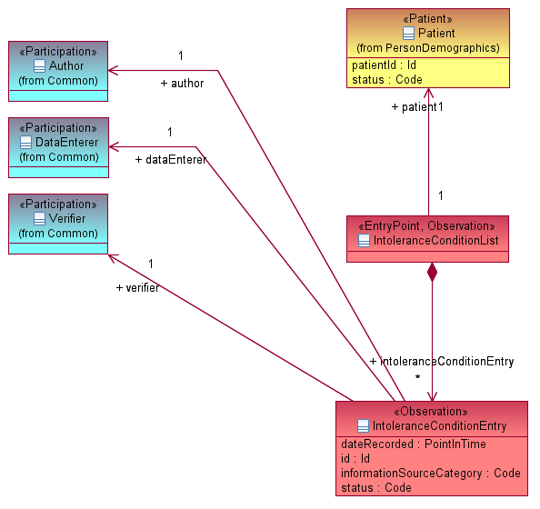

*Figure 1: Annotating classes that are from another domain*

The FHIM was initially populated using existing models contributed by the partner agencies, including the VHA Health Information Model (VHIM), the Biomedical Research Integrated Domain Group (BRIDG) Model, the Common Product Model (CPM), the Integrated Case Safety Report (ICSR), and various other models developed by the agencies directly at HL7. Since the VHIM was the most comprehensive model, it was used as the starting point, with the FHIM modeling style applied. Then each domain is refined by teams comprised of representatives from the partner agencies. Therefore, the FHIM contains domains that are in various states of completion, ranging from not started (aside from the initial application of the FHIM modeling style to the VHIM content) to in progress to completed. The packages are color-coded accordingly (see figure 2).

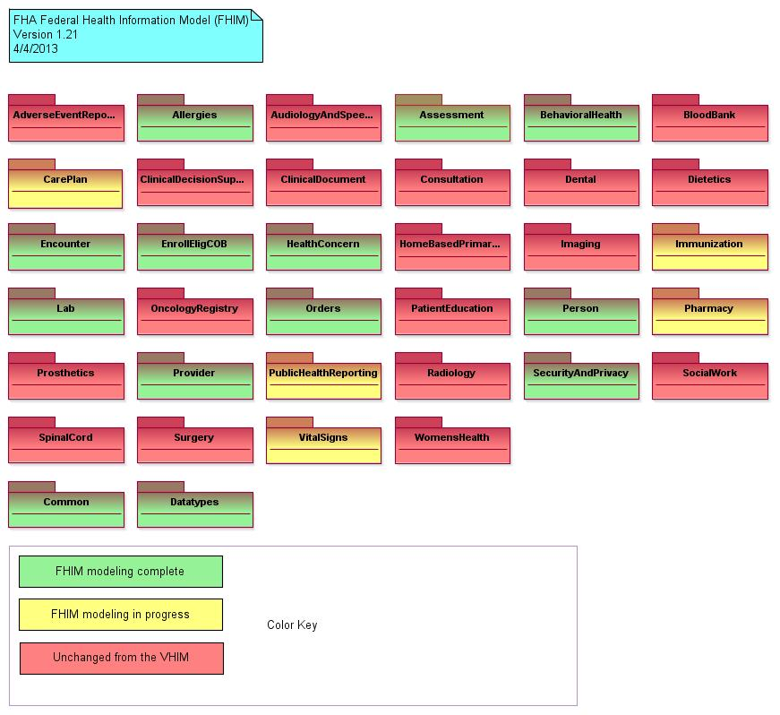

*Figure 2: The FHIM main diagram, showing the top-level domain packages*

The FHIM Domain packages are:

|  |  |
| --- | --- |
| Adverse Event Reporting | Contains concepts necessary to report incidents wherein an injury to the patient has occurred as the result of a medical intervention rather than the underlying medical condition. Adverse events are an unintentional harm to a patient arising from any aspect of healthcare management. This domain is especially oriented toward the reporting of unexpected effects attributable to the administration of one or more medicinal products or the use of one or more medical devices to a jurisdictional public health or regulatory body such as the FDA. |
| Allergies | Contains concepts regarding a patient’s “intolerance conditions”, traditionally known as an “allergy list”. |
| Audiology and Speech Pathology | Contains concepts regarding hearing test results and speech pathology patient registration |
| Assessment | Models Assessment Instruments, which are used in multiple domains, especially behavioral health. |
| Behavioral Health | Contains results of behavioral health assessments that may be shared with SAMHSA or other agencies |
| Blood Bank | Laboratory information regarding testing of Blood Bank products |
| Care Plan | Information regarding interventions and goals planned for a patient |
| Clinical Decision Support | Information regarding patient alerts generated and history of which clinicians were alerted, along with actions taken |
| Clinical Document | Classes representing clinical documents, aligned with HL7’s Clinical Document Architecture (CDA) |
| Consultation | Information related to a request from one clinician to another clinician to provide further services for a patient |
| Dental | Dental examination and appointment data |
| Dietetics | Information on dietetic orders and patient consumption |
| Encounter | Information related to patient encounters |
| Enrollment / Eligibility / Coordination of Benefits | Information related to patient insurance and government program eligibility |
| Health Concern | Data regarding a patient’s “health concerns”, traditionally known as an “problem list” |
| Home-based Primary Care | Information regarding admission and discharge of patients to VA’s Home-based Primary Care program. Used by VA legacy system; may be removed from the FHIM in the future. |
| Imaging | Information regarding the location and retrieval of digital images, including scanned documents. Differs from Radiology in that there is no clinical content, rather just image file management. Used by VA and IHS legacy systems; may be removed from the FHIM in the future. |
| Immunization | Information regarding past immunizations and future scheduled immunizations. Used for both public health reporting and clinical purposes. The legacy VA and IHS systems also contain simple Skin Test information which have been removed from this domain. |
| Lab | Information regarding laboratory orders and results. This domain concentrates on human patient information but does make allowances for food safety and environmental testing. Currently optimized for HITSP C36 (Lab Results). |
| Oncology Registry | Information needed to populate a cancer registry. Includes information on tumors, concomitant diseases, potential contributing factors (smoking, drinking), surgeries and other interventions |
| Orders | Information common to all types of orders and the management of orders throughout their lifecycle. Specific subtypes, such as LabOrder, PharmacyOrder are defined by the respective domains |
| Patient Education | Information documenting the provision of patient education and materials, as this information is often re-used in multiple domains |
| Person | Information about Persons and common roles played by persons, such as Patient and ContactParty. Also includes Birth and Death information. Note that despite the name of the package, this domain also includes Animals which might be patients or subjects of medical inquiries. |
| Pharmacy | Information regarding pharmacy orders and dispenses. This information can also be used to create what is traditionally known as a “medication list.” Currently optimized for NCPDP Script (ePrescribing). |
| Prosthetics | Information needed to order prosthetic devices for a patient |
| Provider | Information about human and organizational Providers to include common information such as licensing, specialties, etc. |
| Public Health Reporting | This domain models those aspects common to all public health reports as well as clinical data needed for specific types of reports |
| Radiology | Information regarding clinical image studies and resulting interpretations. This domain relies on the Imaging domain to locate and manage the image files |
| Security and Privacy | Information regarding access control and privacy policies. This domain is very closely correlated to the HL7 Security and Privacy DAM. |
| Social Work | Models a registry of social work patients, in part for patient management and workload purposes, but also includes information specific to social work which is not currently available elsewhere in the legacy EHR system |
| Spinal Cord Injury | Models a registry of spinal cord injury patients, in part for patient management and workload purposes, but also includes information specific to spinal cord injury which is not currently available elsewhere in the legacy EHR system |
| Surgery | Contains information captured before, during, and after a surgical procedure for a patient |
| Vital Signs | Clinical observations of certain aspects of a patient’s state, traditionally known as an “vital signs” |
| Womens Health | Information summarizing test results for female patients. This domain reflects the fact that legacy IHS and VA systems do not have capability to easily input test results from outside providers. This domain may be retired as the information contained therein is either redundant or a summarization of data that would be existent in a fully defined EHR |
| - | - |
| Common | Contains concepts that are used by more than one domain. These concepts are grouped here primarily for convenience, but also to limit dependencies between packages |
| Datatypes | Contains classes that can be referenced as datatypes by attributes of other FHIM classes. While any class can be used as the type of an attribute in UML, the FHIM modeling style limits datatypes to UML primitive types or those classes in the Datatypes package. All other references between FHIM classes are modeled as associations, not as attributes. |